Baltimore UASI Jurisdictional and Regional Recovery Planning Project Overview
  - <Insert date here>

Introduction
The impacts of a disaster on a community extend far beyond the immediate visible consequences, and can result in long-term negative ramifications to the economy, infrastructure, and well-being of the community. Decisions that affect a community’s ability to recover are frequently made in the first hours and days following a disaster and can prove difficult with complex circumstances. That is why overlooking the critical importance of early recovery planning can be detrimental to the community’s viability for decades in the future.
In Maryland, there are twenty-six jurisdictions, seven of which are members of the Baltimore Urban Area Security Initiative (UASI), including the Cities of Annapolis and Baltimore, and Anne Arundel, Baltimore, Carroll, Harford, and Howard Counties. Disaster recovery, especially in the short-term, will likely be led by the local government, with support from the Baltimore UASI region, state and federal governments, and private and nonprofit partners. In Maryland, there are twenty-six local Emergency Management Offices with Directors who are appointed by the Governor. The Baltimore UASI jurisdictional and regional planning efforts will ensure the Baltimore UASI jurisdictions will be prepared to manage local recovery efforts, and that regional and state support can be coordinated to enhance information- and resource-sharing in support of recovery efforts.

Situation
- Hazards: The Baltimore UASI is susceptible to a wide range of natural and human-caused hazards that have worldwide cascading impacts.
  - Trends indicate that storms and natural disasters will grow increasingly frequent and destructive.
  - Terrorism is on the rise, and remains a persistent threat.
  - Technological and accidental hazards are continuously prevalent.
  - Health hazards pose more of a risk now because of national and international travel advancements.
- Regional and National Implications: The Baltimore UASI is vital to the economic prosperity and security of our nation and, arguably, the world in an era of a globalized economy and supply chains. For example, the Baltimore UASI is a major transportation hub, and includes some of the nation’s major ports, airports, and the I-95 corridor. Additionally, many of the nation’s top national security assets and resources are located within the Baltimore UASI.
- Communication Crisis: Misinformation and rumors can spread quickly, causing negative press to a local jurisdiction.
- Community Impacts: Poor coordination and planning in the aftermath of a disaster can create confusion and chaos, financial loss, closure of local businesses, loss of residents and visitors, mental and behavioral health issues for the community, political ramifications, and many other consequences.
- Disaster Relief Funding Opportunities: In the aftermath of a disaster, communities have been devastated when government, businesses, and residents face the harsh reality that insurance and federal funding programs fall short of expectations and may not help meet every financial loss. While there are several grant and loan programs available, they can prove difficult to navigate, with short deadlines and strict eligibility requirements, leaving businesses and residents with no other option than to leave the community and start over.

Benefit of Recovery Planning
Disasters can be costly – it may take a long period of time to recover from a disaster, and the impacts of a disaster can have significant financial impacts on communities. To help reduce the period of time it takes to recover, and to minimize the financial impacts of a disaster, it is critical to plan for recovery. Recovery planning ahead of a disaster is helpful for many reasons.
- Planning establishes the relationships needed to support disaster recovery.
- Planning can reduce the cost of disasters and ease/expedite the reimbursement process.
- Jurisdictions that understand their roles and responsibilities, and have practiced before a disaster will be better able to perform their roles more effectively, which will help the community recover more quickly.
- Pre-planning will ensure local plans can “speak to” regional plans and state plans, so jurisdictions can get the support they need for recovery operations.
- Public-private partnerships can support recovery efforts and cost-saving initiatives.

The Planning Process Fosters Critical Relationships
One of the major concerns following a disaster is whether it will be possible to restore the community in time to retain residents and businesses. Recovery planning can help with returning the community to an operational level, more quickly, which will support this goal of retaining residents and businesses. The biggest benefits of engaging in the recovery planning process include understanding with whom to coordinate and how to coordinate with them.
The Baltimore UASI Recovery Workgroup is primarily focused on the process of creating the recovery plans, and the foundation for this process involves relationship building. The partners to engage in the recovery planning process include the local offices of emergency management, as well as offices that support economic recovery, local departments of social services, local health departments, local departments of public works, local departments of planning and zoning, as well as private organizations, and nonprofit and faith-based organizations. All of these entities – both governmental and nongovernmental organizations, as well as local citizens, will need to work together to restore their community following a disaster. Engaging in a process that fosters relationships will ensure that recovery coordination will occur quickly and effectively.
The plans that are developed through this process will help to reinforce the relationships that are established during the plan development process by clearly defining the roles and coordination mechanisms agreed to during the planning process.
All of this should help to rapidly restore community services, which should help the impacted community to retain its citizens, who comprise the tax base, and reopen community businesses, which will further support the resumption of community services, and support the restoration of the economy.

Mitigate the Impacts of a Disaster
Disasters are expensive to recover from, but it is possible to receive financial support to assist with recovery for some disasters. Understanding what is eligible for reimbursement, and how to seek financial assistance is part of the planning process, and one of the benefits of pre-planning for recovery. Appendix A includes some of the disaster totals for public assistance for several of the major events that have impacted Maryland, and specifically, the Baltimore UASI jurisdictions over the past six years.
Pre-disaster recovery planning provides an opportunity for cost savings opportunities because it ensures roles and responsibilities, process, and resources are outlined ahead of a disaster. Additionally, planning can help identify potential grant and loan programs that may be available to support recovery efforts. See Appendix B for additional information on the damage assessment process, and grant and loan programs.

Define the Jurisdiction’s Role in Disaster Recovery
Plans help clearly define the roles of various recovery partners. During recovery, the Baltimore UASI jurisdictions are responsible for several key functions, including:
- Sharing information in support of recovery efforts;
- Identifying and prioritizing resource needs and making requests for resources through mutual aid agreements;
- Supporting public safety and providing law enforcement services to protect people’s homes and property; and
- Engaging communities and working to ensure the recovery planning and coordination processes are inclusive of the whole community.
Completing these functions will enable the jurisdictions to prioritize decisions, coordinate recovery operations, ensure the recovery efforts align with the community’s vision for recovery, and manage and meet community expectations throughout the recovery process.
The jurisdictional recovery plans and the Baltimore UASI regional recovery plan will provide strategies and procedures for completing these functions, and the plans will describe the roles and responsibilities of each jurisdiction’s agencies/departments during recovery operations, as well as the roles and responsibilities of each jurisdiction for regional efforts. The plans will also provide guidance for coordinating recovery operations, and supporting information- and resource-sharing at the local, regional, and state levels.

Ensure Local, Regional, and State-level Plan Integration
All disasters begin and end locally, and local jurisdictions may have the ability to manage and recover from an incident without any additional support beyond locally available resources. If a disaster overwhelms a jurisdiction, that jurisdiction may work with other jurisdictions, including counties/cities within its region, for support. The role of the state in disaster recovery is to support the local jurisdictions. When state resources are exhausted, the state may turn to the federal government for support. These efforts all fold together, with the goal of supporting community recovery.
The primary purpose of plan integration is to ensure consistency across plans and planning efforts so that the jurisdictional plans are consistent with the regional plans, as well as the state plans. This will make it easier to coordinate across the levels of government to ensure the needs of impacted communities can be met.

Public-Private Partnerships Help Communities Recover
Following disasters, private organizations, as well as nonprofit and faith-based organizations, such as the Maryland Voluntary Organizations Active in Disaster (VOAD), can play a critical role in helping the community to recover. Successful disaster recovery requires a partnership between the government, and private and nonprofit organizations, as well as the community.
  - “Following a disaster, statistics show ninety percent of companies fail within a year unless they can resume operations within five days”.

  - –Prepare My Business.org
Private organizations can help with cost-saving efforts for local and state governments by performing services that are not well suited to government. As an example, businesses can support recovery efforts by providing needed services and resources to citizens affected by disasters. Local stores can provide things like water and food, and car dealerships can provide services like managing replacing vehicles. If businesses, including small businesses and large companies, can reopen and provide their services and resources, they can provide the community with what they need to return home, help get the community back to work, and the businesses can remain open and sustainable, which helps the economy.
Nonprofit and faith-based organizations also play an important role in recovery, and their active mission is to service the community – they have the capabilities to support recovery efforts across all phases, from short-, to intermediate-, to long-term recovery. The ways they can help include by engaging community members to participate in the recovery process and ensure that community members have access to services. Many people may have more engagement with and trust in their local faith-based organization, which can be a great vehicle for providing information and critical services following a disaster. Additionally, nonprofit and faith-based organizations may be best suited for helping manage volunteers and donations as part of the recovery effort, and may have a role in managing the community’s long-term recovery. Recent case studies for catastrophic recovery operations have demonstrated the critical role of nonprofit and faith-based organizations in meeting the unmet needs of communities and fulfilling some of the needs that the government cannot fulfill.

Overview of the UASI Regional Recovery Planning Process
The development of the jurisdictional and Baltimore UASI regional recovery plans is being led by the Baltimore UASI Recovery Workgroup, chaired by Tom McNeal the Deputy Director of Howard County Office of Emergency Management. Specifically, each Baltimore UASI jurisdiction will develop a recovery plan for their jurisdiction, as well as annexes that address the support functions for recovery. Additionally, the jurisdictions will then work together to develop an all-hazards regional recovery plan to guide the coordination of information- and resource-sharing at the jurisdictional level.
In addition to the development of the plans, the Workgroup will support the Baltimore UASI jurisdictions with developing their recovery programs to ensure each jurisdiction is able to sustain their recovery planning efforts, and maintain their relationships in support of recovery.
The Workgroup is structured to focus on the planning process to ensure each jurisdiction has a clear understanding of their roles and responsibilities in recovery, and that partners in recovery understand their roles and responsibilities. This focus on relationship building and collaboration will ensure that partners in the recovery process are able to work together, and the plans that are developed will support and guide collaborative recovery efforts.

Request for Support from <Local Elected Officials>
All disasters are locally-driven events, and it is the <local official’s> role to provide leadership and policy guidance to their jurisdiction before, during, and after a disaster.
Some actions you can support before a disaster occurs and a need for recovery is indicated include:
- Prioritizing planning for emergencies and disasters;
- Providing policy direction for recovery activities;
- Encouraging all government agencies/departments and private, nonprofit, and faith-based organization to coordinate and collaborate with <your jurisdiction’s> office of emergency management/department of emergency services so that they can contribute to the development of the jurisdictional and regional recovery plans, which will ensure they are better able to perform their roles during recovery;
- Identify additional stakeholders to participate in recovery planning efforts;
- Participating in emergency exercises;
- Understanding the declaration and damage assessment processes to help with receiving needed resource support and reimbursements; and
- Understanding your legal authorities (i.e., implementing a curfew, quarantine measures, evacuation orders, restrictions, closures, etc.) and their effect on response and recovery operations of neighboring jurisdictions.
Some actions you can support following a disaster, when recovery is needed, include:
- Supporting your community throughout the recovery, which can be a long process that may take multiple years; and
- Helping to identify opportunities to build back better and mitigate future damage through mitigation planning and smart infrastructure investments.
Your support is critical to the successful development of your jurisdiction’s recovery plan, as well as the Baltimore UASI regional recovery plan.

Questions
Any questions about the jurisdictional or regional Baltimore UASI regional recovery planning efforts should be directed to:
County OEM Director Name
Title
Email
Phone

OR
The Baltimore UASI Recovery Workgroup
Chair, Tom McNeal
Deputy Director, Howard County Office of Emergency Management
tmcneal@howardcountymd.gov
410-313-5931

Resources
For additional recovery planning information, please see:
- APA, Planning for Post-Disaster Recovery: Next Generation (PAS Report 576) (Dec. 2014), available at http://www.fema.gov/media-library-data/1425503479190-22edb246b925ba41104b7d38eddc207f/APA_PAS_576.pdf.
- FEMA, Effective Coordination of Recovery Resources for State, Tribal, Territorial and Local Incidents (Feb. 2015), available at http://www.fema.gov/media-library-data/1423604728233-1d76a43cabf1209678054c0828bbe8b8/EffectiveCoordinationofRecoveryResourcesGuide020515vFNL.pdf.
- FEMA, National Disaster Recovery Framework (Sept. 2011), available at http://www.fema.gov/media-library-data/20130726-1820-25045-5325/508_ndrf.pdf.

Appendix A
This Appendix includes some of the disaster totals for public assistance for several of the major events that have impacted Maryland, and specifically, the Baltimore UASI jurisdictions over the past six years.
The following tables include the Public Assistance Payment Totals as of November 30, 2015.
Table 1 - December 2009 Severe Winter Storm (2009)
County/Jurisdiction | DR-1875
Anne Arundel | $1,336,478.82
Baltimore City | $1,911,818.24
Baltimore County | $2,856,141.14
Carroll | $0.00
Harford | $746,816.54
Howard | $845,588.56
Totals | $7,696,843.30

Table 2 - 2010 Winter Storm (2010)
 | DR-1910
County/Jurisdiction | Total Eligible | Total Fed. Share | Total Pymts
Anne Arundel | $3,247,075.64 | $2,435,306.78 | $2,435,306.78
Baltimore City | $9,622,515.50 | $7,216,886.76 | $7,216,886.76
Baltimore County | $4,992,419.88 | $3,744,315.01 | $3,744,315.01
Carroll | $1,386,666.12 | $1,039,999.62 | $1,039,999.62
Harford | $1,571,858.51 | $1,178,893.97 | $1,178,893.97
Howard | $1,253,323.97 | $939,993.00 | $939,993.00
Totals | $22,073,859.62 | $16,555,395.14 | $16,555,395.14

The following tables include data from the Maryland Emergency Management Agency Public Assistance Program Open Disaster Declarations - Payments by Jurisdiction Report, effective as of October 19, 2015. These tables show the payments by jurisdiction for the Baltimore UASI jurisdictions. The impacts of many of these disasters have totaled millions of dollars for many of the jurisdictions.
Note:
* | 100% Eligible Costs based on Project Worksheets
** | 75% Federal Reimbursement of Eligible Costs/100% Federal Reimbursement of PA Management Costs
*** | Payments made to date based on project completion
Table 3 - Hurricane Irene (2011)
 | FEMA-4034-DR-MD
County/Jurisdiction | 100%* | 75%** | Payments***
Anne Arundel | $0.00 | $0.00 | $0.00
Baltimore City | $2,216,398.81 | $1,662,299.19 | $1,662,299.19
Baltimore County | $2,322,816.35 | $1,709,029.59 | $1,709,029.59
Carroll | $0.00 | $0.00 | $0.00
Harford | $1,480,044.64 | $1,097,476.56 | $1,097,476.56
Howard | $0.00 | $0.00 | $0.00
Totals | $6,019,259.80 | $4,468,805.34 | $4,468,805.34

Note that the following is the Total Scheduled Payments by County for EM-3335 – Emergency Declaration for Hurricane Irene, which reflects some different numbers because EM-3335 was the Emergency Declaration for Hurricane Irene, which was for Category B work only (Emergency Protective Measures).
Table 4 - Hurricane Irene (2011)
County/Jurisdiction | EM-3335
Anne Arundel | $937,001.31
Carroll | $176,613.73
Howard | $324,865.72
Totals | $1,438,480.76

Table 5 - Tropical Storm Lee (2011)
 | FEMA-4038-DR-MD
County/Jurisdiction | 100%* | 75%** | Payments***
Anne Arundel | $2,075,939.20 | $1,556,819.48 | $1,556,819.48
Baltimore City | $0.00 | $0.00 | $0.00
Baltimore County | $1,400,644.11 | $1,049,895.08 | $295,595.26
Carroll | $0.00 | $0.00 | $0.00
Harford | $1,034,482.93 | $765,974.01 | $765,974.01
Howard | $1,515,420.60 | $1,105,998.48 | $316,978.23
Totals | $6,026,486.84 | $4,478,687.05 | $2,935,366.98

Table 6 - Straight-Line Winds (2012)
 | FEMA-4075-DR-MD
County/Jurisdiction | 100%* | 75%** | Payments***
Anne Arundel | $0.00 | $0.00 | $0.00
Baltimore City | $2,624,935.82 | $1,968,701.88 | $1,968,701.88
Baltimore County | $0.00 | $0.00 | $0.00
Carroll | $0.00 | $0.00 | $0.00
Harford | $0.00 | $0.00 | $0.00
Howard | $0.00 | $0.00 | $0.00
Totals | $2,624,935.82 | $1,968,701.88 | $1,968,701.88

Table 7 - Hurricane Sandy (2012)
 | FEMA-4091-DR-MD
County/Jurisdiction | 100%* | 75%** | Payments***
Anne Arundel | $1,036,796.30 | $777,597.26 | $777,597.26
Baltimore City | $4,246,045.75 | $3,184,534.35 | $2,960,389.33
Baltimore County | $1,109,079.87 | $830,547.29 | $830,547.29
Carroll | $678,984.15 | $509,238.11 | $509,238.11
Harford | $1,713,876.13 | $1,281,855.07 | $1,281,855.07
Howard | $923,283.94 | $692,463.00 | $692,463.00
Totals | $9,708,066.14 | $7,276,235.08 | $7,052,090.06

Table 8 - Snow Storm (2014)
 | FEMA-4170-DR-MD
County/Jurisdiction | 100%* | 75%** | Payments***
Anne Arundel | $0.00 | $0.00 | $0.00
Baltimore City | $0.00 | $0.00 | $0.00
Baltimore County | $3,549,462.50 | $2,662,096.91 | $2,662,096.91
Carroll | $936,128.03 | $702,096.05 | $702,096.05
Harford | $0.00 | $0.00 | $0.00
Howard | $955,650.55 | $716,737.93 | $716,737.93
Totals | $5,441,241.08 | $4,080,930.89 | $4,080,930.89
Other states have also been impacted by some of the recent severe events. For example, the Public Assistance totals for the State of New Jersey following Hurricane Sandy totaled $1,843,156,214.72 – more than a billion dollars in total Public Assistance grants dollars obligated (as of December 3, 2015).

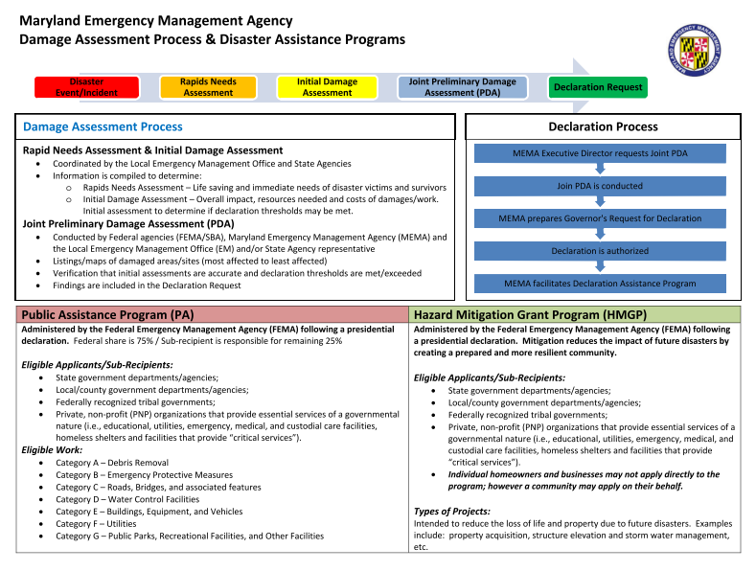
Appendix B

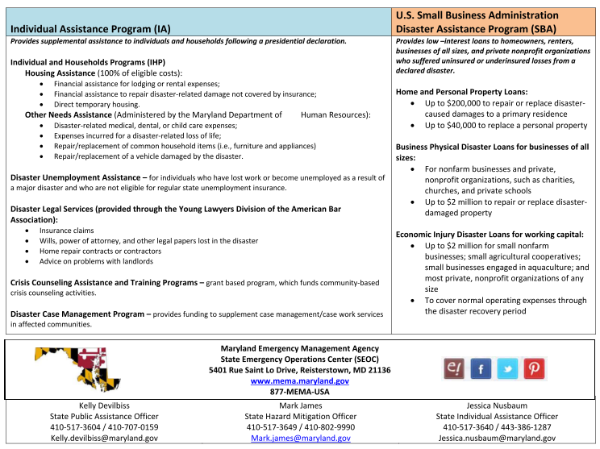

Federal Emergency Management Agency, Strategic Foresight Initiative Driver Papers, available at http://www.fema.gov/media-library/assets/documents/103600 (these “FEMA products explore long-term trends with implications for the future of emergency management”).
Many recovery efforts can take multiple years to complete, such as the recovery efforts in Somerset County, Maryland following Hurricane Sandy, which took approximately three years to complete.
See the tables below on the financial costs of some of Maryland’s recent disasters.
National Center for Preparedness, At the Crossroads of Long-term Recovery: Joplin, Missouri Six Months After the May 22, 2011 Tornado.
New Jersey Hurricane Sandy (DR-4086), available at http://www.fema.gov/disaster/4086.

